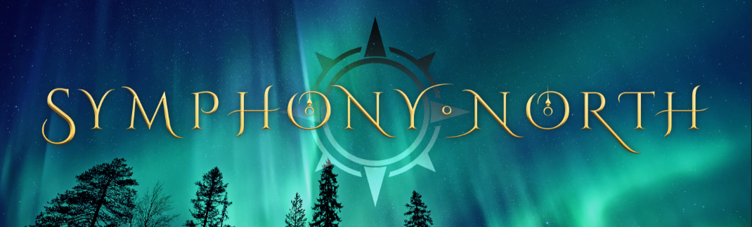

The bell ringer hadn't a thing to give
He was just willing to stand in the cold
And hear every story of suffering
And offer the best self he knows
--from “Gift of Self,” The Bell Ringer
Symphony North is the brainchild of Peter Orullian, former front man for rock and theater legends Heir Apparent and Fifth Angel, with whom he toured internationally. For twenty years, Orullian—also a published novelist (Tor Books)—has sought to combine his passion for music and storytelling with his very real love of Christmas. To that end, he authored a story meant to embody a simple truth: The best gift is the gift of self. Encouraged personally by Paul O’Neill, the late founder and composer of the multi-platinum-selling Trans-Siberian Orchestra (TSO), as well as Chip Davis, the multi-platinum-selling Mannheim Steamroller—the two biggest Christmas acts in the modern era—Orullian put that story to music in The Bell Ringer, a fully-realized holiday symphonic rock and theater experience.
“The combination of music and narrative has such emotional power,” says Orullian. “I’ve loved and studied and performed rock, progressive music, Broadway, and other musical art forms. But I wanted to write a show that did something new. I wanted to write a show that had the raw power of a rock concert, while simultaneously trading on solid narrative principles, from first note to last. And beyond all that, I wanted the character arc to reveal the better part of who we are, that we all have value, that we all have something to offer.”
Orullian’s vision attracted an impressive set of musicians. Featured artists on The Bell Ringer include former TSO recording and/or touring members: Tim Hockenberry (also an America’s Got Talent semi-finalist), Michael Lanning, Jody Ashworth, and Valerie Vigoda, all of whom have extensive Broadway experience. In addition, The Bell Ringer also features members of the Grammy-winning and #1 Billboard-charting band Dream Theater: vocalist James LaBrie; and keyboardist Jordan Rudess (voted by Radar Music Magazine as the Best Keyboardist of All Time).
The Bell Ringer is the debut release from Symphony North, which is based in Seattle, Washington. The album is reminiscent of beloved TSO Christmas records, carrying the edgy influence of progressive rock and metal, as well as the narrative and epic-score sensibilities of Broadway. The record also flashes some of Orullian’s other influences, including the platinum-selling Christmas music of Mannheim Steamroller. Start to finish, the 24-song album tells the story of a bell ringer who, by virtue of his own life’s journey, turns out to be the exact right person to help those whose paths he crosses one Christmas Eve. This simple bell ringer makes a difference by giving of himself, and in turn finds his own sense of self-worth. The album is engineered by Casey Bates (#1 Rock Radio engineer for Portugal the Man). And the band is currently working to like up a national tour to support the album this December.
The Bell Ringer composer Peter Orullian is the recipient of the Private Eye Best Male Vocalist Award. He was also recently chosen by #1 New York Times bestselling writer Brandon Sanderson to collaborate on a new fiction series where music and musicians play a central role. Orullian also recently authored the novelization of the band Dream Theater’s concept album The Astonishing, collaborating with guitarist John Petrucci by bringing his understanding and passion for music and storytelling to the project.
In just a few seasons, Symphony North has started to get noticed by reviewers and fans. In it's first special engagement showcase, Symphony North performed to a packed house, from which it garnered initial agency representation from William Morris Endeavor. A second season tour lead to multiple sold-out shows, sold-out merch tables, and immense direct to consumer business through their website. With the advent of COVID, Orullian took time to write The Bell Ringer as a full novel, the first draft of which is with his literary agent in New York, with a plan for wide release to further bolster and cross-promote the music and the show.
A portion of the proceeds from The Bell Ringer record and its associated tours have been donated to the U.S. Marine Corps Toys for Tots Literacy Program. “Our story is about a man who grew up without a home, and who did his best to make it in the world. His life wasn’t easy. And as an older man, he’s still virtually penniless. But he gives his last dime, his time, his concern, his protection, and whatever wisdom he’s found along the way,” explains Orullian. “So, we liked the idea that in addition to something cheerful that a less fortunate child might receive at the Holidays, we could support them receiving the skills they need to build a brighter future.”
Across its many members, Symphony North has a wealth of experience, including: performing in Tony-nominated Broadway musicals (The Civil War), television (Frasier), America’s Got Talent, and leading the Chacao Youth Symphony. Some members have toured with the likes of Trans-Siberian Orchestra, Nevermore, among others, while others have graduated with advanced music degrees from the prestigious Berklee College of Music. More detail on individual members is available at www.symphonynorth.com/band.
In the end, though, it is the desire to make great music and tell great stories that motivates Symphony North to create their unique sound and live show. “I want to thrill fans,” says Orullian, “and at the same time I want to leave them feeling more hopeful. There’s a feeling you get when a great song inspires you to try little harder, stand a little taller, and maybe extend a hand a little farther. Since I was a kid, I’ve loved the idea that there’s more power and beauty in giving of yourself than any other type of gift. I’ve always believed that the best gift is the gift of self. Our show gives that idea a sound and story.”

